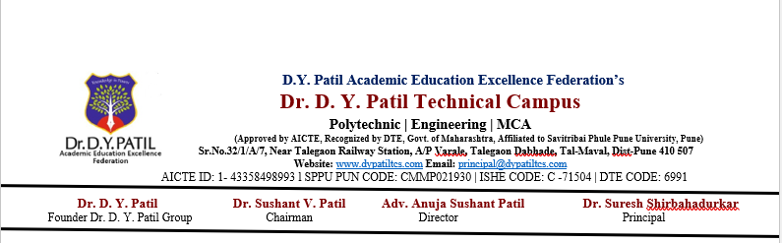
Practical No 5
Problem Statement
Develop a Java program to simulate an ATM machine with functionalities such as checking account balance, depositing money, and withdrawing money. Use try, catch, and finally blocks to handle exceptions like insufficient funds and invalid input, ensuring smooth execution of the application.

import java.util.Scanner;

public class ATMSimulation {

public static void main(String[] args) {

Scanner sc = new Scanner(System.in);

double balance = 5000.0;
int choice;

do {
System.out.println("\n===== ATM MACHINE =====");
System.out.println("1. Check Balance");
System.out.println("2. Deposit Money");
System.out.println("3. Withdraw Money");
System.out.println("4. Exit");
System.out.print("Enter your choice: ");

try {
choice = sc.nextInt();

switch (choice) {

case 1:
System.out.println("Current Balance: Rs. " + balance);
break;

case 2:
System.out.print("Enter deposit amount: ");
double deposit = sc.nextDouble();

if (deposit <= 0) {
throw new IllegalArgumentException(
"Deposit amount must be greater than zero.");
}

balance = balance + deposit;

System.out.println("Amount deposited successfully.");
System.out.println("Updated Balance: Rs. " + balance);
break;

case 3:
System.out.print("Enter withdrawal amount: ");
double withdraw = sc.nextDouble();

if (withdraw <= 0) {
throw new IllegalArgumentException(
"Withdrawal amount must be greater than zero.");
}

if (withdraw > balance) {
throw new ArithmeticException(
"Insufficient balance.");
}

balance = balance - withdraw;

System.out.println("Please collect your cash.");
System.out.println("Remaining Balance: Rs. " + balance);
break;

case 4:
System.out.println(
"Thank you for using the ATM.");
break;

default:
throw new IllegalArgumentException(
"Invalid menu choice.");
}

} catch (ArithmeticException e) {
System.out.println("Error: " + e.getMessage());

} catch (IllegalArgumentException e) {
System.out.println("Error: " + e.getMessage());

} finally {
System.out.println("Transaction completed.");
}

} while (choice != 4);

sc.close();
}
}

